**STAR TOPOLOGY :**

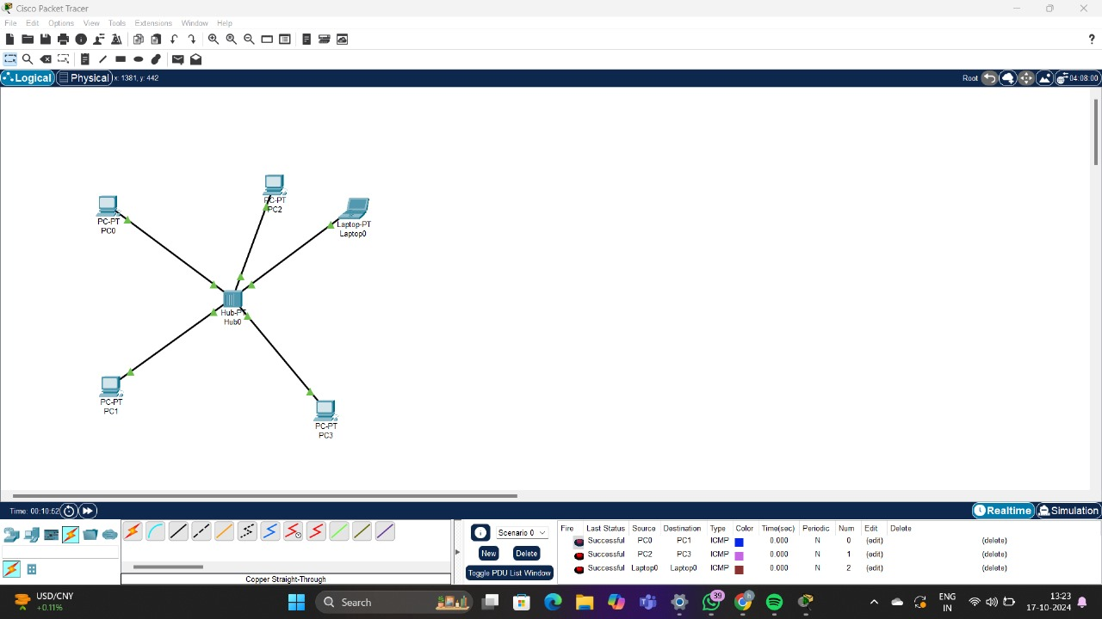

**BUS TOPOLOGY :**

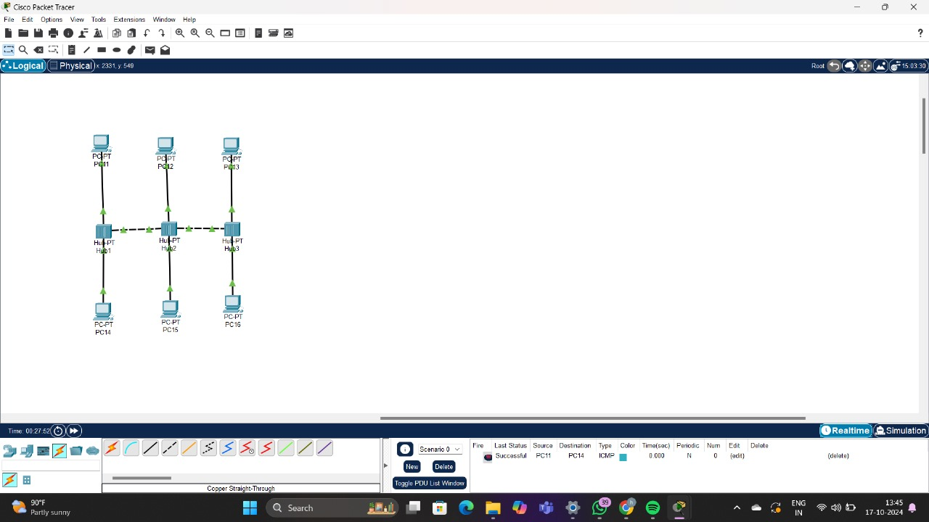

**MESH TOPOLOGY :**

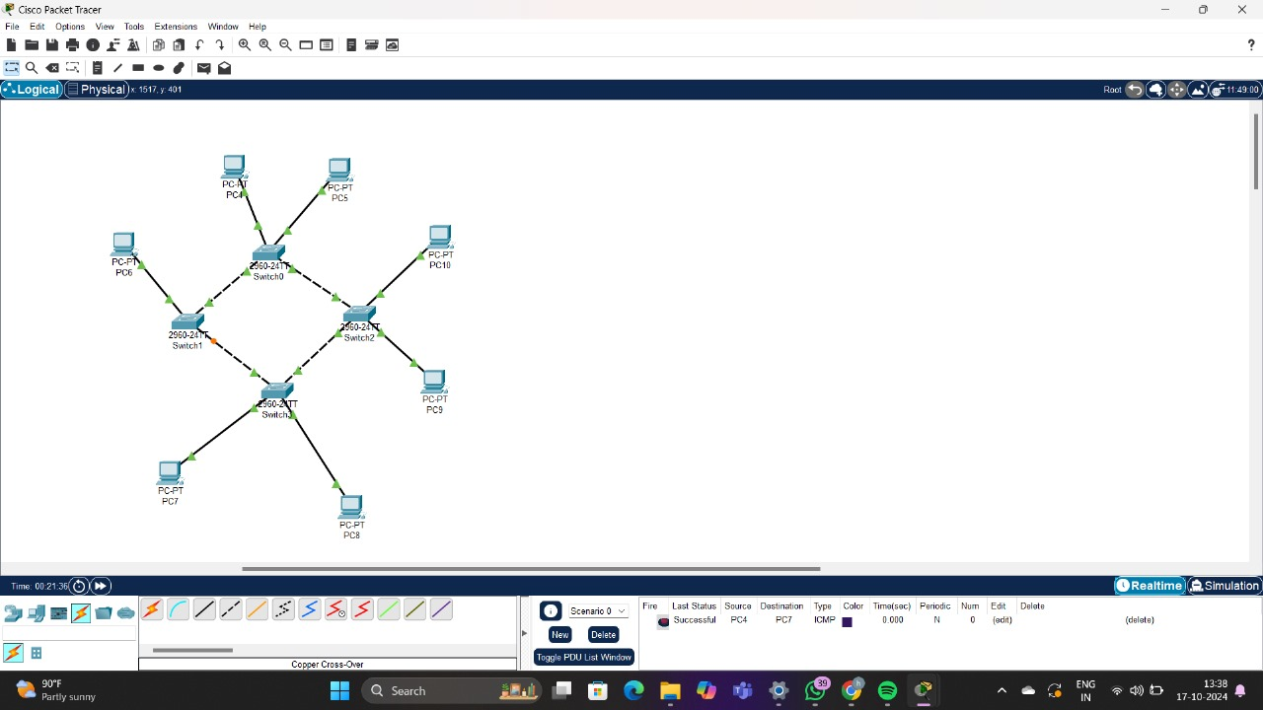

**HYBRID TOPOLOGY :**

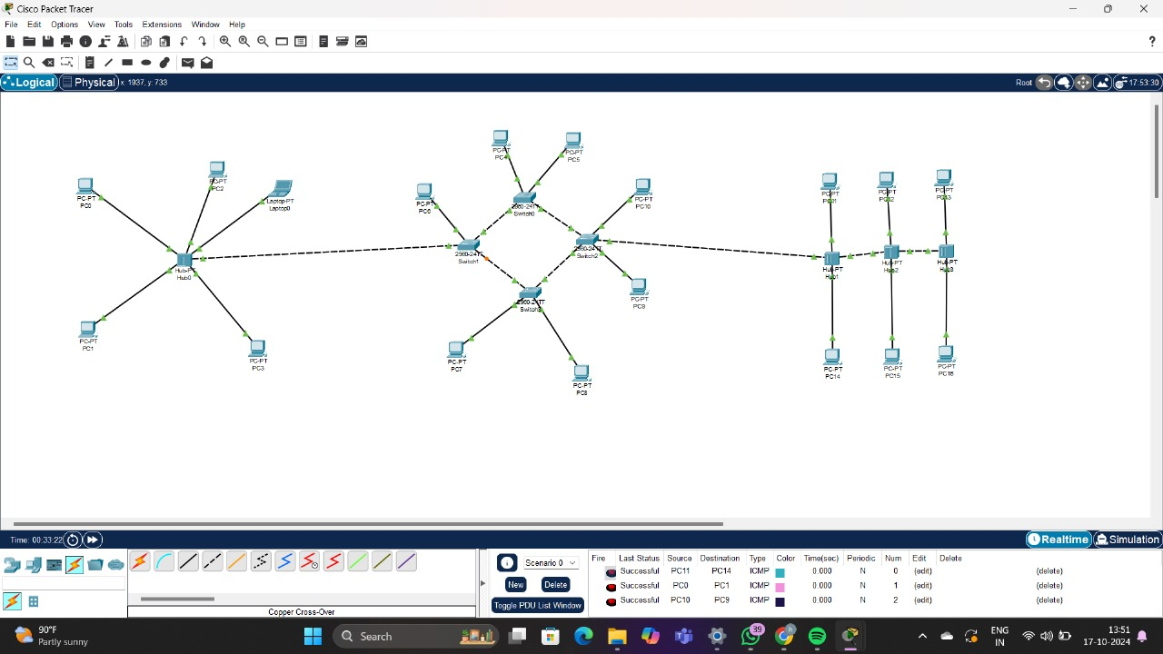

**TREE TOPOLOGY :**

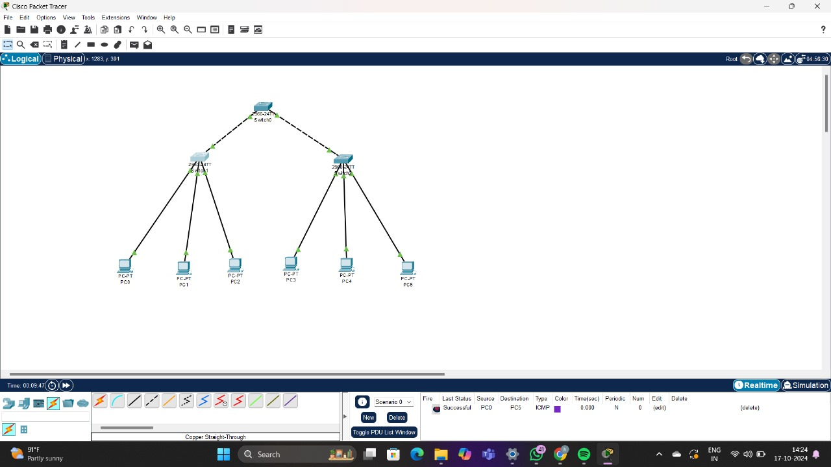

**RING TOPOLOGY :**

